Hybrid silylated hydrogels for biomecules encapsulation: design, stability and controlled release

Corine Tourne-Peteilh,¹ Gilles Subra² and Ahmad Mehdi¹

¹ ICGM, Univ Montpellier, CNRS, ENSCM, Montpellier, France
² IBMM, Univ Montpellier, CNRS, ENSCM, Montpellier, France ; Contact : corine.tourne-peteilh@umontpellier.fr

The delivery of therapeutic bio-macromolecules (i.e. peptides, proteins, nucleic acids and lipids) remains a challenge due to the peculiar instability of these fragile and the wide range of biomedical applications in concern, from vaccination, chronic disease treatment, tissue engineering, to cancer therapy.

A new family of biocompatible hybrid hydrogels, have emerged recently that can cross-link with stable chemical bonds, namely siloxane, Si–O–Si. Inorganic sol–gel polymerization occurs in soft conditions and aqueous media, allowing the inclusion of water-soluble bioorganic molecules. More than, the sol–gel proceeded chemo selectively towards amino acid side chains. This is a key advantage for biomolecules encapsulation during the loading process, as it avoids unwanted side reactions involving the biomolecule of interest.

In this context, different silylated hydrogels, have been evaluated as hybrid matrices able to trap, stabilize and release model drugs. Different forms could be achieved such as microgels, by O/W/O double emulsion¹ or microfluidics² approaches, as well as films or monoliths. The inner structure and composition of the network are easily tunable to reach complex drug encapsulation¹ (i.e. lipophilic and hydrophilic), or to sustain release of biomolecules (proteins) over weeks.³ Fine tuning the sol gel conditions allows to adjust the hybrid material network mechanical properties, as well as functionalizing the silylated polymer backbone with other silylated species.

For example, we were able to adapt the mechanical properties of the hybrid hydro- or xerogels, as a function of a desired protein delivery rate, from hours to several weeks. The release mechanisms were driven by several factors including the penetration of aqueous medium inside the hybrid materials resulting in the swelling, the protein diffusion, and the erosion of the material.³

Beyond this proof of concept, the perspectives of designing tailored hybrid hydrogels for encapsulating biomolecules are as wide as the range of available silylated (bio) polymers and other hybrid biomolecules that may constitute the network. Besides the hybrid polymer nature, the crosslinking density, the hydrophilic/hydrophobic balance and even the isoelectric point of the gel could be chosen according to the biomolecule to be delivered and the desired timeframe for delivery.

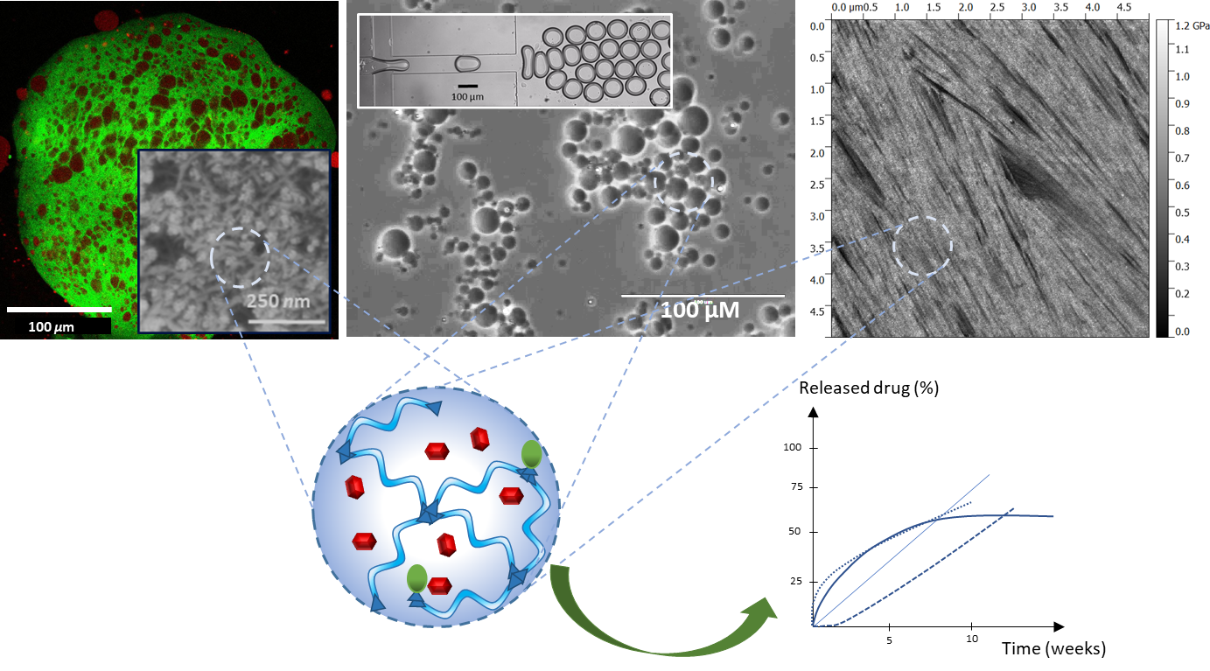

1 M. Zayed, C. Tourne-Peteilh, M. Ramonda, G. Rethore, P. Weiss, J. Martinez, G. Subra, A. Mehdi, J.-M. Devoisselle and P. Legrand, International Journal of Pharmaceutics, 2017, 532, 790–801.
2 C. Tourne-Peteilh, B. Robin, M. Lions, J. Martinez, A. Mehdi, G. Subra and J.-M. Devoisselle, Chem. Commun., 2019, 87, 13019–13186.
3 C. Tourné-Péteilh, M. Barège, M. Lions, J. Martinez, J.-M. Devoisselle, A. Aubert-Pouessel, G. Subra and A. Mehdi, RSC Adv., 2021, 11, 30887–30897.

