Sol-gel polymerization: a biorthogonal chemistry for the preparation of biomimetic hydrogels
Cécile Echalier,^{1*} Laurine Raimond,^{1,3} Mathieu Simon,² Laurine Valot,^{1,3} Titouan Montheil,^{1,3} Danièle Noel,² Jean Martinez,¹ Ahmad Mehdi,³ Gilles Subra¹
¹ IBMM, Univ Montpellier, CNRS, ENSCM, Montpellier, France
² IRMB, Univ Montpellier, INSERM, CHU, Montpellier, France
³ ICGM, Univ Montpellier, CNRS, ENSCM, Montpellier, France
*cecile.echalier@umontpellier.fr
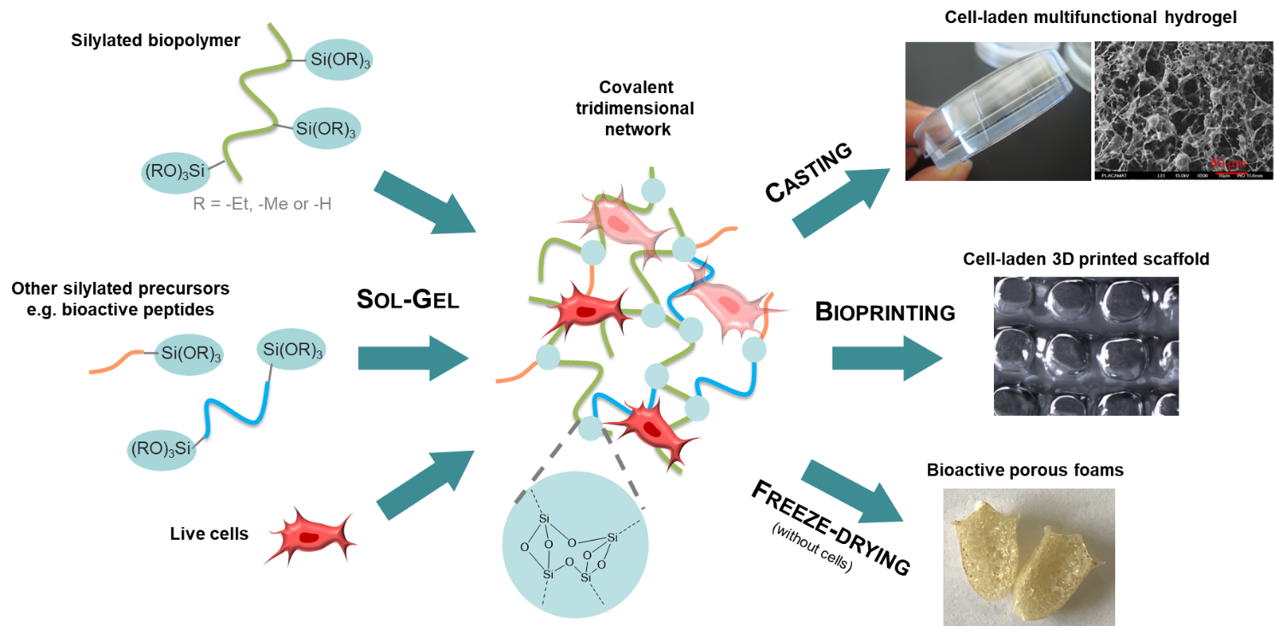
The sol-gel process is a versatile cross-linking chemistry to develop customized biomimetic matrices for regenerative medicine.^{1,2}
The introduction of alkoxysilane groups onto biomolecules yields hybrid silylated biomolecules that can be engaged in the sol-gel process. This inorganic polymerization proceeds under mild conditions to create covalent siloxane bonds between silylated building blocks. Upon solubilization of precursors in biological media, hydrolysis and condensation reactions occur leading to a covalent bio-inorganic tridimensional network.
The method was applied to the preparation of hydrogels based on synthetic polymers (polyethylene glycol),³ peptides (collagen-inspired),^{4,5} polysaccharides (HPMC, hyaluronic acid, chitosan)^{6,7} and, more recently, proteins (gelatin)⁸. Interestingly, the sol-gel chemistry is suitable not only for cross-linking the network but also for covalently functionalizing it. One-pot functionalization with bioactive peptides or fluorophores provides additional properties to the materials such as cell-adhesive or antibacterial activities.³ We demonstrated that live cells, in particular stem cells, can be encapsulated during the polymerization without affecting their viability and function.^{5,6,9} Cell-laden solutions can be casted or used as bioinks to 3D print porous scaffolds.^{6,9,10}
This work paves the way to the design of tailor-made artificial matrices for tissue engineering applications.

1 T. Montheil, C. Echalier, J. Martinez, G. Subra and A. Mehdi, J. Mater. Chem. B, 2018, 6, 3434–3448.
2 T. Montheil, M. Simon, D. Noël, A. Mehdi, G. Subra and C. Echalier, Front. Bioeng. Biotechnol., 2022, 10, 888437.
3 C. Echalier, C. Pinese, X. Garric, H. Van Den Berghe, E. Jumas Bilak, J. Martinez, A. Mehdi and G. Subra, Chem. Mater., 2016, 28, 1261–1265.
4 C. Echalier, S. Jebors, G. Laconde, L. Brunel, P. Verdié, L. Causse, A. Bethry, B. Legrand, H. Van Den Berghe, X. Garric, D. Noël, J. Martinez, A. Mehdi and G. Subra, Mater. Today, 2017, 20, 59–66.
5 L. Valot, M. Maumus, L. Brunel, J. Martinez, M. Amblard, D. Noël, A. Mehdi and G. Subra, Gels, 2021, 7, 73.
6 T. Montheil, M. Maumus, L. Valot, A. Lebrun, J. Martinez, M. Amblard, D. Noël, A. Mehdi and G. Subra, ACS Omega, 2020, 5, 2640–2647.
7 T. Montheil, L. Raimond, L. Valot, M. Maumus, M. Simon, J. Martinez, M. Amblard, D. Noël, A. Mehdi and G. Subra, ACS Appl. Polym. Mater., 2022, 4, 4087–4097.
8 M. Simon, M. Maumus, B. Legrand, L. Sole, M. Dufaud, A. Mehdi, C. Jorgensen, D. Noël and G. Subra, Biomater. Adv., 2023, 147, 213321.
9 L. Valot, M. Maumus, T. Montheil, J. Martinez, D. Noël, A. Mehdi and G. Subra, ChemPlusChem, 2019, 84, 1720–1729.
10 C. Echalier, R. Levato, M. A. Mateos-Timoneda, O. Castaño, S. Déjean, X. Garric, C. Pinese, D. Noël, E. Engel, J. Martinez, A. Mehdi and G. Subra, RSC Adv, 2017, 7, 12231–12235.

